Implementation – Reference Implementation

The reference implementation relies heavily upon the extensions that are attached as part of the engine. Thus to see how the reference implementation was designed we would refer to look at those extensions.

The extensions the reference implementation uses:

**Logger Extension** this is used to log all actions that occur inside the engine and to log any errors that might also occur.

**EIS Extension** this extension is used to connect the reference implementation to our goal program for the agents inside the reference implementation.

**Tile World Extension** the reference implementation uses a Tile based world as such it directly uses the Tile World Extension that provides just this functionality.

The reference implementation as such only provides:

* Actions specific to the reference implementation(Grabbing/releasing packages)
* Entities specific to the reference implementation(Walls, Player, etc.)
* Percepts and modules specific to the reference implementation(Holding package percept)
* A view in console form
* A Goal program
* A way to control an agent with keyboard

# The console view

The console view is designed is optimized to draw the screen at a specific frame rate. When the console view does not draw it will instead update all view data is has stored.

To change view data in a view, an event must be fired from the model, however since the model is operating on a different thread than the view. The view must ensure no concurrent errors. This is done by using the ##ThreadSafeEventMananger, as explained in **[INSERT VIEW IMPLEMENTATION REFERENCE]**.

The console view works by drawing the screen, then if it has time between left before the next drawing is scheduled the view will execute a single event on the ##ThreadSafeEventManager. The view will continue this process until either, there is no events left to be executed or the time is up and it is time for it to perform the next drawing of the screen. On fig. **[FlowOfConsoleDrawing]** a drawing of this process can be seen.

This provides the reference implementation with a very quickly updated view as no time is wasted on the thread and instead will continue to update even when it is not drawing. Furthermore by updating the view data in a separate thread the engine core does not use its computation power on handling this making the engine overall more efficient.



**[Note(FlowOfConsoleDrawing): the sequence of the console view drawing process]**

# Goal Program implementation

The goal program is designed to work directly with our reference implementation, as it is just a show case of how such a program might look like, it will make assumptions based on how the reference implementation interact. For instance it will assume that there are entities called walls that are meant to block off tiles.

To see the source code of our goal program commented, look in appendix **[GOALCODEAPPENDIX].**

# Agent decision

A full flow chart of the goal program decision chart can be found on appendix **[INSERT GoalFlowChart Appendix reference]**.

As can be seen from the flow chart, the agent will try and find packages and bring them to a dropzone, if no such packages can be found or if no dropzone is found, the agent will start exploring the entire world.

The goal program operates with a few different notions;

**Street** the first notion is the notion of streets. A tile is a street if it contains no wall types such a normal walls or impassableWalls(map boundaries walls) this means that the agent can move on this tile.

**Route** all the agents decisions are preplanned this means that the agent determines where to move to, this plan is put into a route, the agent will follow this route whenever it has nothing else to do, such as grabbing/releasing packages.

**Explored** the agent’s goal is to eventually have all tiles explored as this means that all packages has been collected from the world. The agent determines that a tile has been explored if it has seen all its adjacent tiles. This works great for the agent because until it reaches a wall the unexplored tiles that it has stored as a street will always be considered unexplored, no matter how far it moves, this makes the agent work much like putting a carrot in front of a mule, no matter how much the agent explores whenever it explores something, there is always something new that becomes unexplored. As such this will continue until a wall has been reached on all its paths.

A tile is determined to be explored if all tiles adjacent to has been seen by the agent, fig. **VisionExploredGoalAgent** shows an image of this.

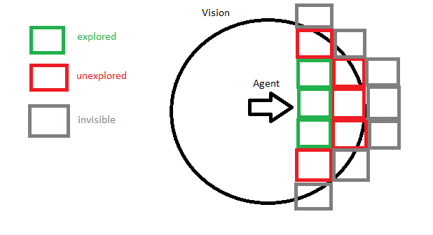

**[Note(VisionExploredGoalAgent): An image of an agent’s vision and which it would determine to be explored]**

# Summary

The reference implementation was designed as a reference for all the features of the engine, as such it made heavily use of the extensions that we implemented. This section only covered the view and the goal program in details. This is because most of the reference implementation consists of either declaring new agent/entity types or wiring all the extensions together, as such there was almost no business logic involved which makes them rather uninteresting to explain in detail.

One part that the reference implementation does not cover which could have been interesting was the notion of linked module as explained in **[System feature modules].** This could have been used in the reference implementation but we did not choose to do so.

Overall the design of the reference implementation is very solid and fulfills the goals we had for it, which were to be a showcase for our engine.